Prediction based on Macro Analysis, Fundamental Analysis and Technical Analysis

**Team Members**

Gurpreet Singh Sodhi

Shahan Ahmed

Peter Lieberman

Nicole Mann

Etan Winograd

**Project Description / outline**

In the field of Finance, we have different types of subject matter experts, namely Macro Economics Analysis, Fundamental Analysts and Technical Analysts.

Our project brings these different fields together and predicts the daily directional move. For this project, we will predict crude and gold prices.

The model will have four different ML models.

Macro Economics Analysis – This ML model will consume economic indicators and predict the economic cycle. The output will be classification.

Fundamental Analysis – This ML model will consume fundamental data relevant to the underlying and predict the daily move. Since we are predicting crude and gold, we will consume Futures data for this project. The output will be multiple classification models.

Technical Analysis – This ML model will consume price data and create technical indicators before processing and predicting the daily price change. The output will be multiple classification models.

Aggregator – This ML model will consume data from the above three models and predict the daily change of the underlying. The output will be classification model.

**Research questions to answer**

We want to combine three different streams of Finance (Macro, Fundamental and Technical) and predict the daily price move.

**Rough breakdown of tasks**

All team members will participate in various tasks. However, below is the list of team members with their primary responsibility

Fundamental Analysis Gurpreet Singh Sodhi

Technical Analysis Etan Winograd

Web interface Shahan Ahmed

Aggregator Peter Lieberman

Macro Economics Nicole Mann

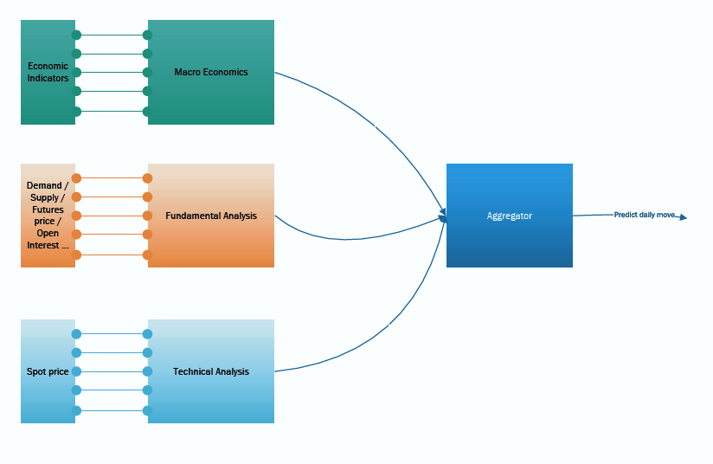

**Demonstration Instructions:**

Our application is built on web technologies including HTML, CSS, PHP & JavaScript. The application is hosted on a Linux web-server located at this address: [Arb-Bot 2.0](http://iamsha001.club/columbia/index.php) Once you arrive at the applications homepage, create a new account, if required.

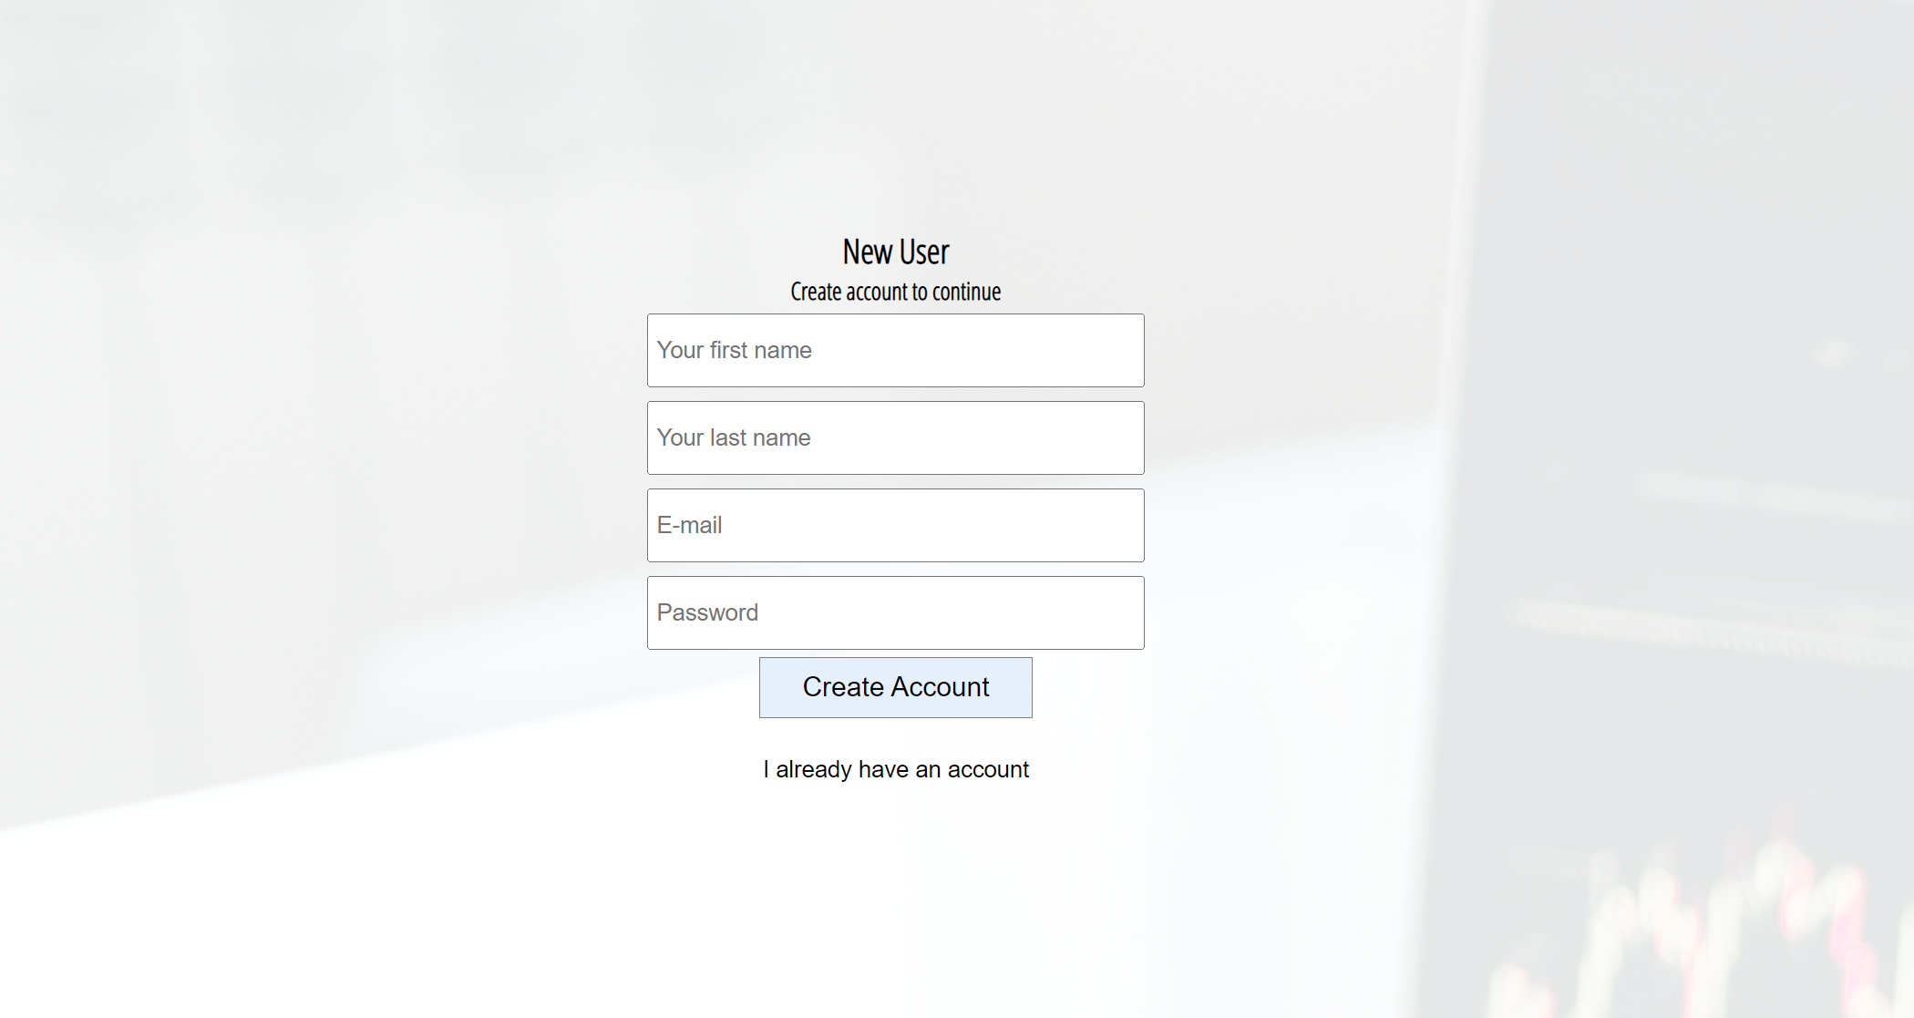

After you have created your account, click the “**Analyze ( Project 2)**” icon, and you will be directed to the Analyze tab where our project is focused.

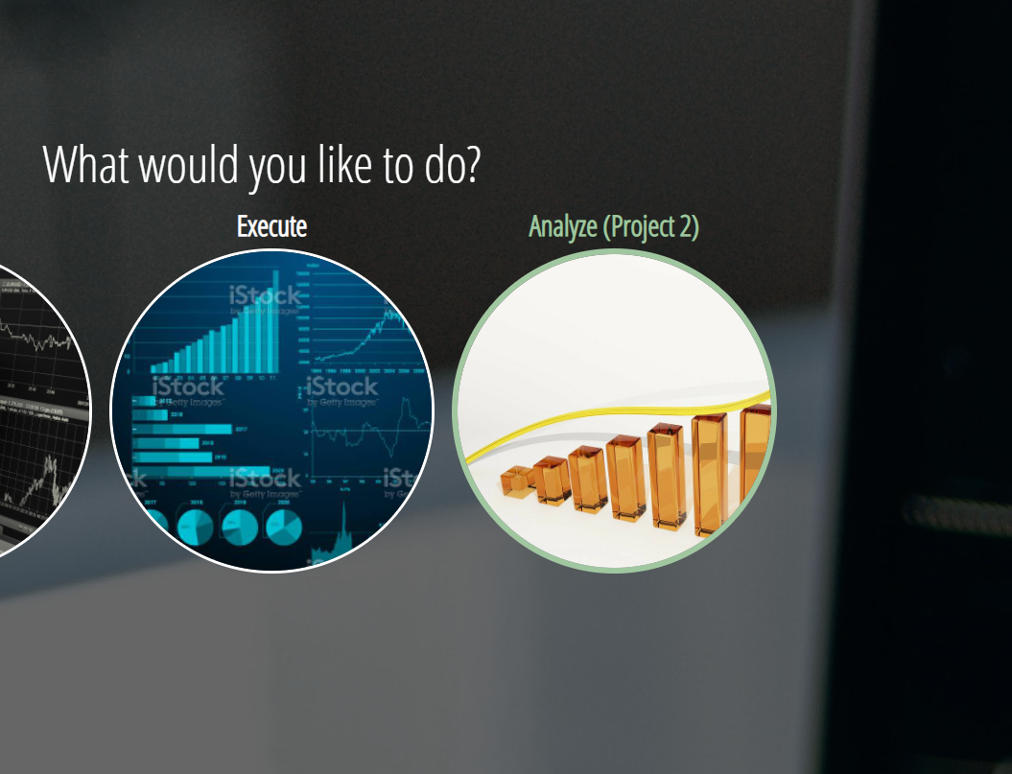

Using the “Fine Tune Analysis Panel”:

You will notice the panel has 4 sections – Fundamental Analysis, Technical Analysis, Macro Analysis, Aggregate Analysis. Each of the sections allow the user to modify different parameters to further fine-tune their analysis. As this is only a demonstration, leave all the default parameters already given, **scroll to the bottom** of the panel, and click the **“Execute All”** button. This will make a request to our backend server and run the respective python files. The fundamental, technical and macro will each output their result files into our aggregate function. This process can take up to 30 seconds, so be patient, and you will be presented with the outputs from all 4 of the analysis.

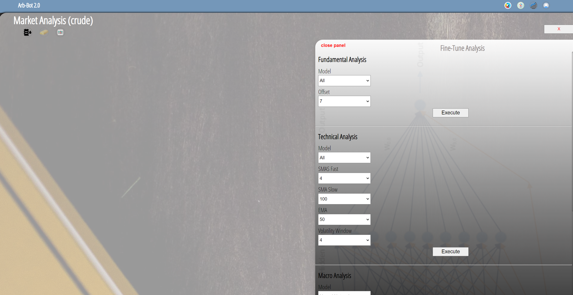

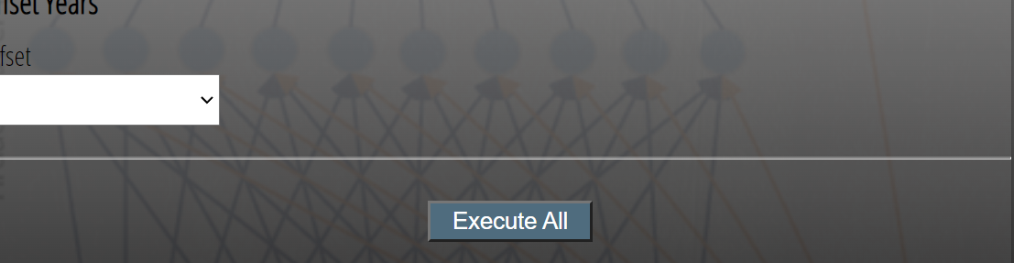

After the process has completed, you should see all the results from our four analyses on the screen:

